Latest Round-ups:
Season 2019/20
#14
Midweek Action: 11 of the 16 Les Phillips Cup matches beat the weather during the week, with the tie at Brislington postponed due to floodlight issues. Games in Devon were worst hit, with Buckland, Exmouth and Tavistock all seeing their matches called off, while excessive rainfall also meaning Bishops Lydeard and Keynsham will play their first round tilt at a later date.
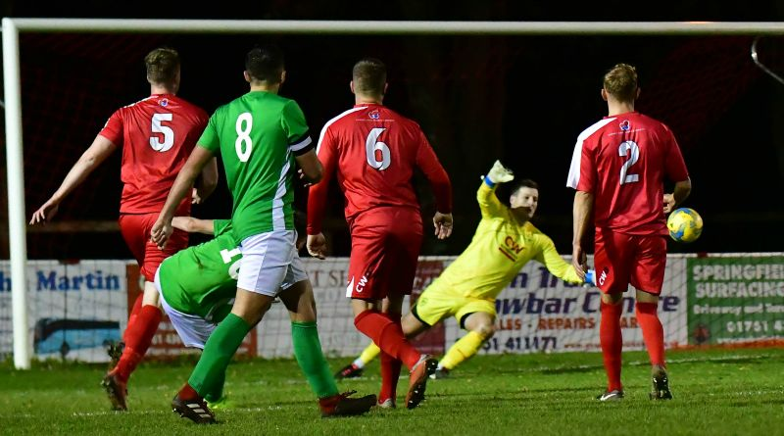
Tuesday evening saw three of the four away sides prevail, with Bitton requiring penalties to see off the challenge of Ashton & Backwell United at the Lancer Scott Stadium. After the Premier Division side stormed into an early two-goal lead through Karim Rendall and Josh Egan, Ashton produced an excellent fightback, leading with 12 minutes left on the clock thanks to Paul Uppington, Joe Bishop and an own-goal. Bitton weren’t behind for long however, and after a goal from Mitch Tippins had seen them secure the 3-3 draw, the higher ranked team then beat their hosts 5-3 on spot kicks. Goals in either half from Aron Robbins helped Hallen defeat Devizes 3-0 at Nursteed Road, while Street saw off Radstock by the same scoreline thanks to efforts from Kyle Strange, Kameron Andrews and Olly Pearson. There was late heartbreak for Welton who were denied a penalty shootout away at Cribbs, after George Kellow scored in the 3rd minute of stoppage time to give the home side victory by the slimmest of margins.
Action from Street’s Les Phillips Cup victory over Radstock, courtesy of John Newport.
Wednesday saw a plethora of goals, with five of the seven victors scoring at least four times during their wins. Wells City were one of the teams to flex their goalscoring muscles, with Craig Herrod, Tom Hill, Harry Foster and Harvey Hadrill all on target during their 4-0 victory away at Corsham. Another team to win big away from home were Shepton Mallet who stormed out of the blocks during their 4-0 defeat of Hengrove. Jack Fillingham and Aaron Seviour each struck in the opening five minutes to put the visitors in control, with Tyrone Tucker-Dixon adding a third midway through the first half prior to Fillingham wrapping up victory with his second of the evening. Another side to make a fast start were Clevedon Town, where first half doubles from both Jay Murray and Syd Camper proved enough to hold off a fightback from Chipping Sodbury, with the Seasiders eventually winning 4-2.
Bridgwater Town went one better than Clevedon, with three goals after half-time helping them beat Odd Down 5-2. A pair of early goals from Jack Taylor looked to have set Bridgwater up for an easy victory, but the Bath side had other ideas, and were level at the break after Adnan Hiroli and Harry Keen each found the back of the net. Tom Ellis then headed the home side back in front ten minutes into the second half, before the same man then scored again seven minutes from time to put the result beyond doubt. There was still time for Taylor to complete his hat-trick, with the skipper finishing well after being teed up by strike-partner Steve Murray. Warminster Town were another team to hit five, with Francois Allen, Lewis Graham, George Butler, Nyke Fletcher and Jack Miluk all netting during their comprehensive victory over Portishead. In the most surprising result of the round, Longwell Green Sports managed to claim a 1-0 win away at Premier Division outfit Westbury. The game didn’t involve a tonne of goalscoring chances, so when Luke Bryan struck for the visitors midway through the second half it turned out to be enough for them to grab victory. At Oaklands Park, Roman Glass St George were forced to come from behind to beat Premier Division strugglers Bridport. Having suffered two heavy defeats over recent times, things looked rosy for Bridport when Max Westlake handed them the lead just prior to the half-time break. Roman Glass have been bang in form recently however, and after Matt Guy grabbed an equaliser, George Box then struck in injury time to complete the turnaround and hand them a spot in the second round.
FA Vase: Buckland Athletic progressed to the next round thanks to a 1-0 win away at South West Peninsula League leaders St Austell. The game was decided in the closing stages, with Stuart Bowker scoring the only goal 20 minutes from time to knock out their Cornish hosts. It was a successful day all round for the Western League sides, with Plymouth Parkway defeating Brockenhurst 3-0. Parkway were rewarded for their strong start to the game when Jordan Copp put them ahead in the 25th minute, with top scorer Adam Carter then doubling their advantage just before the break. Brockenhurst have an impressive home record this season, but they were no match for the Devon side who added a third 15 minutes from time through substitute Teigan Rosenquest. In the third game to survive, Warminster Town were terrific during their 3-1 win at home to Portchester, with first half goals from Francois Allen and Jack Miluk paving the way for their second round victory. Cribbs made it four out of four for Western League sides on Sunday afternoon thanks to a 3-1 extra-time victory away at Thornbury Town. Having gone ahead on the hour mark thanks to a Jake Hodgson header, Cribbs were denied victory during normal time, when Brandon Benjamin levelled affairs in the 83rd minute. The away side took no time at all in regaining their advantage during the extra 30 minutes, with Jordan Yeo forcing an own goal within 60 seconds of the restart. Then, with 119 minutes on the clock, Cribbs confirmed their spot in the next round thanks to a well taken goal from Ethan Feltham.

Premier Division: Hallen made a dream start to the month of November, moving up to fourth spot following a big 5-0 win at home to Brislington. The home side only led by one goal at the break with the in-form Aron Robbins putting them ahead in the 13th minute. Robbins then struck again early in the second half, taking advantage while one of the visiting players was spending time in the sin-bin. The final half-hour of the contest belonged exclusively to Sacha Tong, who took just 15 minutes to produce a perfect hat-trick, scoring with both his left and right feet, before completing his treble with a header as Brislington capitulated in the closing stages. There was also a big win for Westbury, who bagged five second half goals to claim a 6-2 victory away at Keynsham Town. Having given his side a half-time lead, Callum Demkiv took it upon himself to double his personal and Westbury’s tally early in the second half to make it 2-0 to the visitors. Joe Stradling then got in on the act, scoring Westbury’s third, before Matt Long pulled a goal back for Keynsham with a tidy finish at the back-post. The Wiltshire side regained control during the final quarter with Ricky Hulbert restoring their two-goal lead prior to a late double from Sam Jordan which sandwiched Jamie Price’s effort for the hosts. In the only other Premier Division fixture to beat the weather, Shepton Mallet picked up their first three points in over a month by beating Wellington 2-1. Following a goalless opening half, Shepton made a dream start to the second half, going ahead 100 seconds after the restart, only for Wellington to level things five minutes later through Luke Boyle. Shepton had a big midweek win in the cup, and they managed to back that up with another victory, when Kieran Bailey headed home Andy Martin’s corner 20 minutes from time.
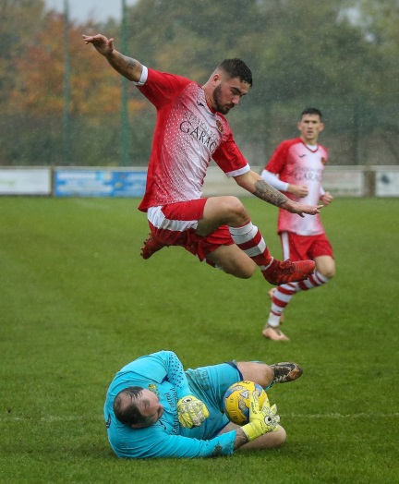
First Division: They may be at opposite ends of the table, but the clash at Bremhill View between Calne and Bristol Telephones was a tight affair decided by one moment of magic. It was league leaders Calne who ended up taking home all three points, with Stuart Windsor lobbing the visiting keeper from 20 yards three minutes into the second half. Sherborne produced a late fightback to come from behind and defeat Lebeq United 2-1 at Raleigh Grove. Having trailed since the half hour mark, Sherborne got back on level terms 15 minutes from time when Alex Murphy found the back of the net. With both sides pushing for a winner, it was Sherborne who came up trumps, with Murphy striking again to single-handedly turn the game in the hosts favour. Corsham Town have risen up to sixth in the league after beating Hengrove 2-1 at the Southbank Ground. It took just four minutes for Corsham to go ahead in tough conditions, with Ash Alchin tapping home following a pull back from the influential Lewis McCarron. Hengrove managed to force home an equaliser during the first half, but then with 15 minutes remaining, McCarron dusted himself down after being fouled and sent in a dangerous free-kick which found its way to James Gardner who fired home Corsham’s winner.
Action from Corsham’s 2-1 win over Hengrove Athletic, courtesy of John Cuthbertson.
Western League Statistical Leaders

PREMIER DIVISION LEADING GOAL SCORERS (League only):
Adam Carter (Plymouth Parkway) – 17
Jack Taylor (Bridgwater Town) – 9
Jack Fillingham (Shepton Mallet) – 9
Lucas Vowles (Clevedon Town) – 9
Josh Egan (Bitton) – 9
Gary Higdon (Bradford Town) – 9
Tyson Pollard (Bradford Town) – 9

PREMIER DIVISION TOP ATTENDANCES:
Bridport 0 Bridgwater Town 6, Sunday 6th October 2019 – 347
Wellington 0 Exmouth Town 2, Sunday 6th October 2019 - 315
Plymouth Parkway 1 Exmouth Town 0, Wednesday 21st August 2019 - 308

FIRST DIVISION LEADING GOAL SCORERS (League only):
James Rustell (Radstock Town) – 14
Harry Foster (Wells City) – 11
Stuart Windsor (Calne Town) – 11
Adam Wright (Cheddar) – 10
Danny Carter (Longwell Green Sports) - 10

FIRST DIVISION TOP ATTENDANCES:
Warminster Town 2 Bristol Telephones 3, Saturday 5th October - 369
Portishead Town 3 Longwell Green Sports 5, Saturday 5th October – 262
Devizes Town 0 Ashton & Backwell United 1, Saturday 5th October – 252

LEADING SCORERS IN ALL COMPETITIONS:
Jack Crago (Tavistock) - 20
James Rustell (Radstock Town) – 19
Adam Carter (Plymouth Parkway) – 18
Harry Foster (Wells City) – 15
Jack Taylor (Bridgwater Town) - 15
Jack Fillingham (Shepton Mallet) – 14
Gary Higdon (Bradford Town) – 13

*All goalscoring stats via
Full-Time FA website
Latest Results
Tuesday 29th October 2019
Les Phillips Cup – First Round
Ashton & Backwell United 3-3 (3-5 pens) Bitton 64
Cribbs 1-0 Welton Rovers 52
Devizes Town 0-3 Hallen 50
Radstock Town 0-3 Street 66
Wednesday 30th October 2019
Les Phillips Cup – First Round
Bridgwater Town 5-2 Odd Down 72
Clevedon Town 4-2 Chipping Sodbury Town 72
Corsham Town 0-4 Wells City 41
Hengrove Athletic 0-4 Shepton Mallet 62
Roman Glass St George 2-1 Bridport
Warminster Town 3-0 Portishead Town 68
Westbury United 0-2 Longwell Green Sports 44
Saturday 2nd November 2019
Premier Division
Hallen 5-0 Brislington 72
Keynsham Town 2-6 Westbury United 137
Shepton Mallet 2-1 Wellington 148
First Division
Calne Town 1-0 Bristol Telephones 65
Corsham Town 2-1 Hengrove Athletic 48
Sherborne Town 2-1 Lebeq United
FA Vase – Second Round
AFC St Austell 0-1 Buckland Athletic
Brockenhurst 0-3 Plymouth Parkway
Warminster Town 3-1 AFC Portchester 222
Sunday 3rd November 2019
FA Vase – Second Round
Thornbury Town 1-1 (1-3 AET) Cribbs

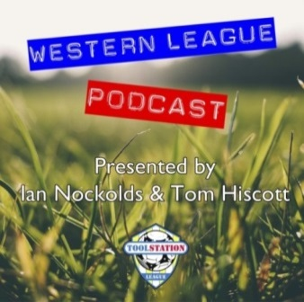

Be sure to check out the latest podcast, where Ian, Tom & guests recap all the latest news and results from around the Western League. To follow along all season, each broadcast will be available at the following link: http://www.toolstationleague.com/podcasts.php

Upcoming Fixtures
Tuesday 5th November 2019
FA Vase – Second Round
Bitton vs Fairford Town 19:30KO
Petersfield Town vs Roman Glass St George 19:30KO
Premier Division
Shepton Mallet vs Cribbs 19:30KO
Wednesday 6th November 2019
FA Vase – Second Round
Baffins Milton Rovers vs Bradford Town 19:45KO
Saltash United vs Bridgwater Town 19:45KO
Tavistock vs Exmouth Town 19:45KO
Premier Division
Westbury United vs Bridport 19:30KO
Les Phillips Cup – First Round
Bishops Lydeard vs Keynsham Town 19:30KO
Friday 8th November 2019
First Division
Wincanton Town vs Cheddar
Saturday 9th November 2019 (KICK OFF AT 3.00PM UNLESS NOTED)
Premier Division
Bradford Town vs Shepton Mallet
Bridgwater Town vs Cadbury Heath
Brislington vs Bitton
Buckland Athletic vs Tavistock
Clevedon Town vs Keynsham Town
Exmouth Town vs Cribbs
Plymouth Parkway vs Chipping Sodbury Town
Street vs Odd Down
Wellington vs Hallen
Westbury United vs Roman Glass St George
First Division
Almondsbury vs Bishops Lydeard
Ashton & Backwell United vs Radstock Town
Bishop Sutton vs Warminster Town
Bristol Telephones vs Welton Rovers
Calne Town vs Sherborne Town
Devizes Town vs Wells City
Hengrove Athletic vs Portishead Town
Lebeq United vs Oldland Abbotonians 15:15KO
Longwell Green Sports vs Corsham Town

League Tables
Premier Division
 |  | P | W | D | L | F | A | GD | PTS
1 | Bradford Town | 12 | 10 | 1 | 1 | 39 | 13 | 26 | 31
2 | Plymouth Parkway | 10 | 8 | 1 | 1 | 43 | 8 | 35 | 25
3 | Bridgwater Town | 12 | 7 | 3 | 2 | 39 | 18 | 21 | 24
4 | Hallen | 13 | 7 | 2 | 4 | 27 | 24 | 3 | 23
5 | Exmouth Town | 9 | 7 | 0 | 2 | 22 | 5 | 17 | 21
6 | Brislington | 15 | 7 | 0 | 8 | 23 | 38 | -15 | 21
7 | Westbury United | 12 | 6 | 2 | 4 | 27 | 20 | 7 | 20
8 | Clevedon Town | 12 | 6 | 1 | 5 | 25 | 27 | -2 | 19
9 | Bitton | 10 | 6 | 0 | 4 | 29 | 16 | 13 | 18
10 | Street | 12 | 6 | 0 | 6 | 30 | 27 | 3 | 18
11 | Shepton Mallet | 10 | 5 | 2 | 3 | 21 | 16 | 5 | 17
12 | Buckland Athletic | 11 | 5 | 1 | 5 | 20 | 21 | -1 | 16
13 | Keynsham Town | 11 | 4 | 2 | 5 | 23 | 28 | -5 | 14
14 | Cadbury Heath | 13 | 3 | 5 | 5 | 18 | 26 | -8 | 14
15 | Cribbs | 13 | 4 | 2 | 7 | 16 | 30 | -14 | 14
16 | Roman Glass St George | 9 | 4 | 0 | 5 | 25 | 12 | 13 | 12
17 | Tavistock | 8 | 3 | 2 | 3 | 19 | 16 | 3 | 11
18 | Wellington | 13 | 3 | 1 | 9 | 16 | 33 | -17 | 10
19 | Odd Down | 13 | 3 | 1 | 9 | 13 | 32 | -19 | 10
20 | Bridport | 15 | 3 | 1 | 11 | 21 | 55 | -34 | 10
21 | Chipping Sodbury Town | 13 | 2 | 1 | 10 | 13 | 44 | -31 | 7

First Division
 |  | P | W | D | L | F | A | GD | PTS
1 | Calne Town | 12 | 8 | 2 | 2 | 20 | 7 | 13 | 23
2 | Wincanton Town | 11 | 7 | 2 | 2 | 25 | 17 | 8 | 23
3 | Ashton & Backwell United | 11 | 6 | 4 | 1 | 19 | 14 | 5 | 22
4 | Wells City | 11 | 6 | 2 | 3 | 29 | 18 | 11 | 20
5 | Longwell Green Sports | 10 | 6 | 1 | 3 | 23 | 17 | 6 | 19
6 | Corsham Town | 13 | 6 | 1 | 6 | 24 | 35 | -11 | 19
7 | Radstock Town | 10 | 6 | 0 | 4 | 25 | 20 | 5 | 18
8 | Lebeq United | 12 | 6 | 0 | 6 | 26 | 23 | 3 | 18
9 | Sherborne Town | 10 | 6 | 0 | 4 | 20 | 19 | 1 | 18
10 | Cheddar | 11 | 5 | 2 | 4 | 21 | 17 | 4 | 17
11 | Oldland Abbotonians | 11 | 4 | 4 | 3 | 10 | 13 | -3 | 16
12 | Portishead Town | 9 | 4 | 1 | 4 | 24 | 20 | 4 | 13
13 | Bishops Lydeard | 10 | 4 | 1 | 5 | 20 | 19 | 1 | 13
14 | Almondsbury | 10 | 4 | 1 | 5 | 16 | 18 | -2 | 13
15 | Warminster Town | 11 | 4 | 0 | 7 | 23 | 18 | 5 | 12
16 | Welton Rovers | 11 | 3 | 2 | 6 | 13 | 22 | -9 | 11
17 | Devizes Town | 10 | 2 | 4 | 4 | 20 | 20 | 0 | 10
18 | Hengrove Athletic | 11 | 2 | 3 | 6 | 7 | 28 | -21 | 9
19 | Bishop Sutton | 10 | 2 | 1 | 7 | 13 | 19 | -6 | 7
20 | Bristol Telephones | 12 | 1 | 1 | 10 | 16 | 30 | -14 | 4

